Table of Contents
Introduction 1
Quick setup guide 1
Step-by-step setup guide 2
GitHub (website) 2
GitHub Desktop setup 2
Usage: Visual Studio Code installation 3
Step-by-step usage guide 3

Introduction
The ORM app is an open-source modular controller for Raman microscopes, supporting various motorized stages, camera, and spectrometer models from major manufacturers (Thorlabs, Princeton Instrument, Ocean Insight, Physik Instrumente, and Zaber). This document aims to guide new users on how to setup, use, and update the ORM controller. A technical guide for developers is also available in the /docs directory. Additionally, a brief intro to the ORM system and app including some use-case examples can be found in the readme page in GitHub.
This guide is structured as follows:
- Quick setup guide for users with programming backgrounds
- Contribution guide
- Step-by-step setup guide for users without programming backgrounds
- Step-by-step usage guide
- Step-by-step update guide
- Step-by-step contribution guide

Quick setup guide
ORM’s GitHub repository can be found at: [insert url here] and the app is started by running main_controller.py in the root folder. The required packages are listed in ‘the requirements.txt’ file and prior to the first run, a config file has to be set up (git-ignored). This can be done by first running the main_controller.py file, which will automatically copy all the necessary config files. The main config file is the library/config.py (will be moved to root/config.ini in later versions), which holds all the key global variables for the controller choice, communication port definition, instrument serial number definitions, etc. Please configure these parameters first before moving forward. To test the controls of specific instruments, we recommend putting in ‘dummy’ in all controllers’ global variables except for the one being tested. This is especially useful to pinpoint specific communication problems with the instrument during setup.
Updates are generally rolled out through the ‘main’ branch and please refrain from pushing directly into main, instead doing so through pull-request from branch tied to an issue in GitHub. Naturally, feel free to contact us for any questions or comments; we are reachable through GitHub’s issue/discussion panel, or directly through kevin.uning.23@ucl.ac.uk.

Step-by-step setup guide

GitHub (website)
To start with, it is important to note that the app is hosted through GitHub. “GitHub is a developer platform that allows developers to create, store, manage and share their code. It uses Git software, providing the distributed version control of access control, bug tracking, software feature requests, task management, continuous integration, and wikis for every project.” wikipedia description of GitHub (https://en.wikipedia.org/wiki/GitHub). Or in short, it’s a platform to share and track updates of the app. This is important as GitHub allows updates and bugfixes to be rapidly deployed into your system, provides a checkpoint to previous working versions of the app, and allows you to keep various versions of the app (e.g., if you’re testing a new feature, developing new controllers, etc.). Thus, the authors hope that the users will try to familiarize themselves with the GitHub platform. This is a very nice, brief intro video to GitHub, which covers the main talking points of this document as well (https://youtu.be/v_1iqtOnUMg?si=S7n5bHfcFtaQZhPW).

GitHub Desktop setup
Traditionally, GitHub repositories are tracked (updated, etc.) using git, which has to be operated in a terminal. Understandably, this can be difficult to do for users without programming background so instead, the authors suggest using the GitHub Desktop instead that has a nice Graphical User Interface (GUI), as shown in Figure 1.
[insert tutorial video url here]
https://www.youtube.com/watch?v=P8z4MEGcxh0&ab_channel=TalkingtechwithTechielass
https://www.youtube.com/watch?v=CLrv9Jcv7Bg&ab_channel=TalkingtechwithTechielass
https://www.youtube.com/watch?v=PoZNIbs_wx8&ab_channel=TalkingtechwithTechielass
[insert ORM’s GitHub url here]

Visual Studio Code (VS Code)
Upon cloning the repository from GitHub into your computer (through GitHub Desktop), code can be opened using a program called ‘Visual Studio Code’, which is an editor like word but, is also equipped with powerful tools to quickly edit the code, and importantly help debug, compile, and run the code. Here’s two brief tutorial videos (you can skip them if you want, the only important thing to know is how to open a file/folder, run a code and stop them, which will be covered in the next section).
https://youtu.be/B-s71n0dHUk?si=sROUsegvMlj8NVVy
https://youtu.be/EUJlVYggR1Y?si=raCLQOeW_rym_xKS

Python installation, virtual environment setup, and package installations
Once VS Code is installed, the next step is to install Python itself, which can be done through the official Python website (https://www.python.org/downloads/). The app was tested in:
Python 3.11 and Python 3.12
Unfortunately, Python 3.13 is not currently supported as one of the key packages, pythonnet, is not yet available for it.
Key option during installation:
- Please check “Add Python to environment variables”, this will make things a lot easier when setting up the packages in the next steps
- If this step is skipped during installation, you can run the installer again and select Modify > Add Python to environment variables, and selecting install again
Please restart the computer once Python has been installed. This is important to register Python in the computer’s main search paths.
Once restarted, open the ORM root folder in VS Code (which can be done either through GitHub Desktop or through VS Code itself, though we recommend opening it using GitHub Desktop to familiarize ourselves with it). Next, we shall set up a virtual environment for the app. A virtual environment is a local ‘environment’ where all packages will be installed to prevent any future interference between packages’ callsign, installation versions, etc. In short, it will install and isolate the packages that will be used by ORM into a folder. This is done with the following steps:
- Press “ctrl + shift + p” to open the VS Code’s command palette, and type in “Python: Select interpreter”
- Select “+ Create Virtual Environment” > “Venv”
- Select the Python version to be the base of the virtual environment
- Wait until the virtual environment is installed
Finally, the packages can now be installed into the virtual environment. This can be done by typing in “py -m pip install [… package name…] == […version…]”. The required packages can be found in the ‘requirements.txt’ file in the root folder. Once all the packages have been installed, the ORM app is now ready to be configured and started.

Config file setup
The ORM controller has one main file, which will automatically connect with the other files to grab their functions, parameters, etc. This main file is the main_controller.py which can be found in the root folder. Running this will automatically initialize the software and the instruments based on the configuration in the config file. For this, it is important to first set the config file according to your physical setup. The steps are as follows:
- Run the main_controller.py. Don’t worry if it gives you an error message, this first run is to automatically generate the config files necessary.
- Go to the ‘./library/config.py’ file and set the necessary parameters. Those of particular importance are:
  - STAGE_INVERT: To invert the x and y coordinate frame of reference
  - VIDEOFEED_HEIGHT: Controls the camera feed size
  - CAMERA_MIRROR: Mirrors the camera feed
  - LASER_WAVELENGTH_NM: For the Raman shift calculation
  - PLT_MAP_SIZE_PIXEL: Controls the heatmap plot size
  - PLT_SIZE_1D_PIXEL: Controls the 1D plot size
  - …_CONTROLLER: Instruments of choice!
  - CAMERA_EXPOSURE_TIME: Camera exposure time one way of controlling the sensitivity of the camera’s exposure
  - And some other instrument-specific parameters, e.g., COMPORT, serial number, etc.
- Go to the ‘./library/app/config_shortcuts.py’ file to set the keyboard shortcuts for the app.

Step-by-step usage guide
Once the config files are set, the ORM app can be started by running the main_controller.py file. Once started, the app should immediately start reporting its loading progress in the terminal, starting with the imports, followed by the instrument setups, and finally the app itself.
Once opened, you will be greeted with two windows: a spectrometer calibration window, and the main controller window, as shown in Figure 1. Here, the spectrometer can be calibrated (pixel mapping and intensity transfer function) if required
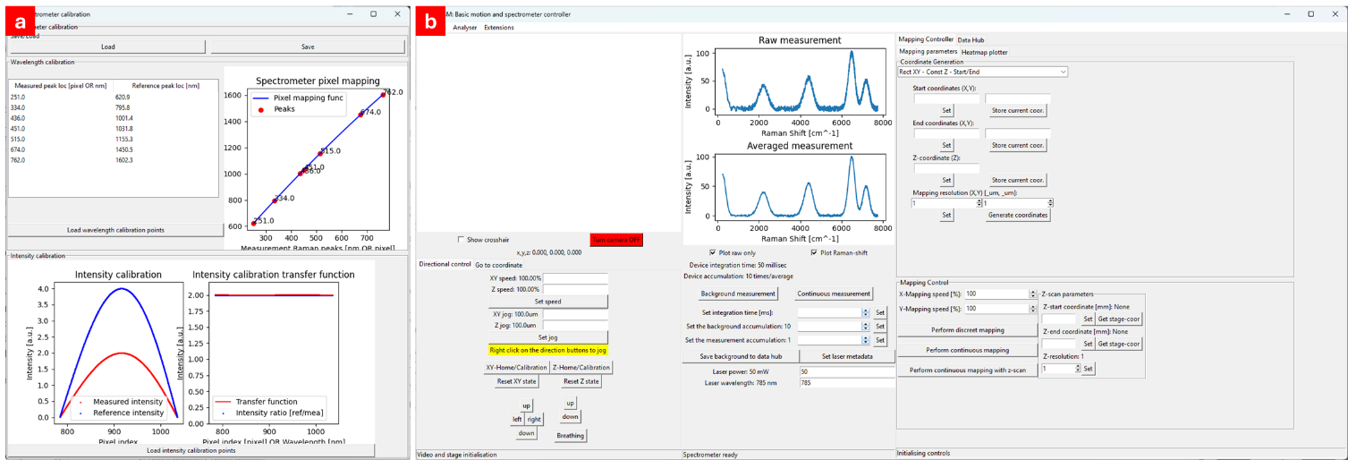
Figure 1. ORM’s spectrometer calibration window (a) and main controller window (b)

Step-by-step update guide

Step-by-step contribution guide

